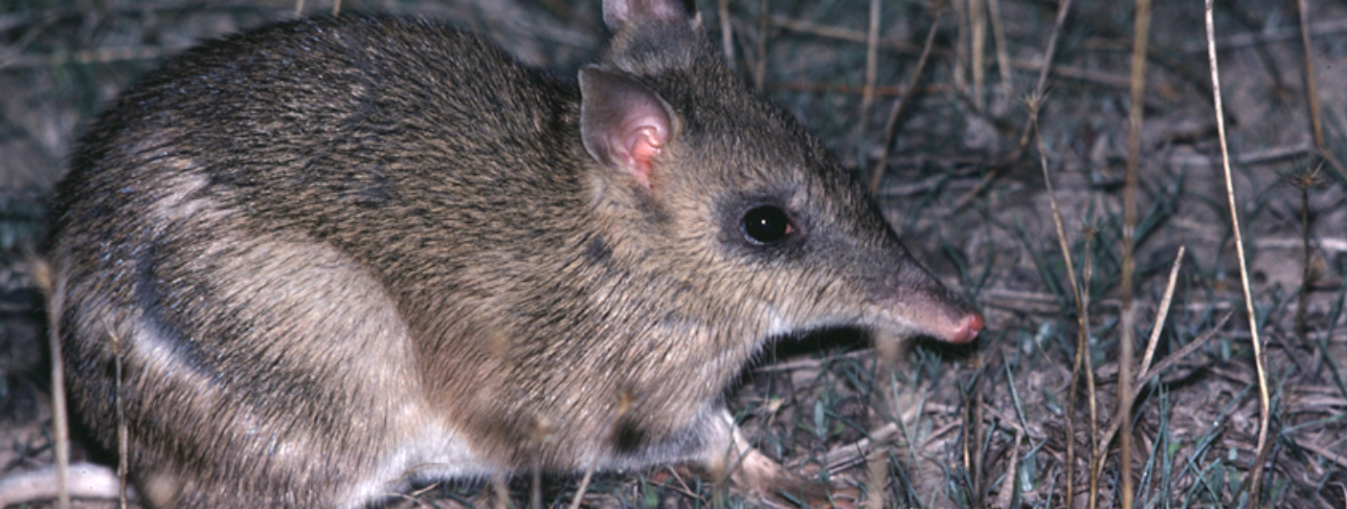
Duration
Rod Bird ©
Activity 2
Comparing plant and animal adaptations

Objectives
After completing this activity, students will be able to:
- Recognise grassland and granite outcrop habitats
- Identify and compare adaptations of animals from grassland and granite outcrop habitats.

Target audience
Year 5

One 50-minute session

Materials
- Student worksheet
- Pencil
- Class set of computers with access to the BWVP Mt Rothwell Virtual Tour (internet access is required) and the BWVP Flora and Fauna Field Guide (on iPhone or iPad) or on the Ecolinc BWVP website (internet access is required)

Activity
Before beginning the activity
This activity focuses on the adaptations of plants and animals living in grassland and granite outcrop habitats. Students will compare these adaptations to determine whether these animals and plants could survive in the other habitat. Discuss with students the characteristics of each habitat, and how plants and animals have adapted to survive in them.

Carrying out the activity
- Students access the Mt Rothwell Virtual Tour on their computers. Initially ask students to look at the aerial map view to identify the locations of the grassland and granite outcrops. A grassland is treeless and is dominated by grasses and herbs. A granite outcrop is an exposure of granite rock (a very hard, igneous rock), with grasses, occasional shrubs and trees.
- Students will click on each of the 11 points along the trail from the aerial map view, view the images and determine whether the point is located in a grassland or granite outcrop. Points 1, 2 and 11 are grassland sites, while points 3, 4, 5, 6, 7, 8, 9 and 10 are granite outcrops. Students will then complete Questions 1-3 in their workbooks.
- Students will then focus on adaptations of plants and animals in both habitats. In Questions 4-5, they should find three animals from each habitat, and using the BWVP Flora and Fauna Field Guide, determine their physical characteristics and why the animals live in that particular habitat. As Mt Rothwell is at the edge of the Western Volcanic Plain some of the animals do not appear in the BWVP Flora and Fauna Field Guide. Therefore, students should select another animal or find the information using another source e.g. Museum Victoria Field Guide to Victorian Fauna.
- Student will then explore various points along the trail within the Virtual Tour in Question 6, to find adaptations for plants and animals and determine whether they are structural or behavioural.
- Students should share their findings with the class. Ask students to discuss their findings. Students should then complete the conclusion questions.

Comparing plant and animal adaptations
Investigate the adaptations of grassland and granite outcrop organisms within the BWVP Mt Rothwell Virtual Tour by completing the following questions.
- Access each of the points along the trail from the aerial map view and study the features to determine whether the point is found in a grassland or granite outcrop. Record your results in the table below.
Point | Grassland habitat | Granite outcrop habitat
1 | ✓
2 | ✓
3 |  | ✓
4 |  | ✓
5 |  | ✓
6 |  | ✓
7 |  | ✓
8 |  | ✓
9 |  | ✓
10 |  | ✓
11 | ✓

- Describe the granite outcrop habitat?
The granite outcrop is a dry, open eucalypt woodland to 15 m tall often with a sparse shrub layer. The understorey is dominated by a carpet of herbs and grasses. There are undulating, rounded granite hill landforms.
- Describe the grassland habitat?
A grassland habitat is treeless, with vegetation mostly < 1 m, and dominated by large grasses and herbs.

All organisms have adaptations that enable them to survive and thrive. Some adaptations are structural, which are physical features of an organism e.g. the beak of a bird. Other adaptations are behavioural. These are behaviours an organism uses to survive e.g. a bird’s call.

You will identify the structural adaptations of animals and determine why the animal lives in a particular habitat.
- Identify three animals that live in the grassland and granite outcrop habitats. Use the BWVP Flora and Fauna Field Guide to determine their structural adaptations or physical characteristics (look up the identifying characteristics and distinctive markings).

Grassland fauna | Physical characteristics | Granite outcrop fauna | Physical characteristics

- Could the selected animals live in one or both habitats?
Animals that require long grass and herbs for food and protection may be found in both habitats as both provide this cover. Animals that require large rocks, shrubs and trees may only be found in the granite outcrop habitat.
- Look up the following points along the trail to find an example of a plant or animal adaptation. Identify whether it is a behavioural or structural adaptation.
Point | Name of plant or animal | Adaptation | Structural or behavioural adaptation
3B | Sheoaks | Have developed a symbiotic relationship with mycorrhizal fungi enabling them to fix their own nitrogen (used for growth). | Structural
3D | Mosses | They have no vascular system to transport water and nutrients. They grow together in a group to support one another and to help retain water. | Behavioural
6A | Tawny Frogmouth | They have silver-grey plumage, which makes them difficult to see amongst the branches of the eucalypts where they roost. | Structural
6C | Hedge Wattle | They have dense growth and sharp spines. | Structural
8D | Red-rumped Parrot | They are well camouflaged when feeding on the ground. | Structural
8E | Short-beaked Echidna | A long pointed snout is used for probing the soil and turning over rocks to access ant mounds. They also use their long sticky tongues to catch their food.  They dig themselves into the ground if threatened. | Structural  Behavioural

Conclusion
- How does the granite outcrop and grassland habitat vary?
The granite outcrop is a very rocky habitat with the occasional trees and shrubs, whereas the grassland is treeless. Some basalt outcrops may be found in grasslands.
- Identify animals found in the granite outcrop?
Students should mention the animals they have investigated. These could include mammals such as the Brush-tailed Rock Wallaby, reptiles such as the Common Blue-tongue Lizard and birds such as the Wedge-tailed Eagle.
- Identify animals found in the grassland habitat?
Student should mention the animals they have investigated. These could include: mammals such as the Rufous Bettong and birds such as the Bush-stone Curlew.
- What is the difference between a structural and behavioural adaptation?
A structural adaptation is a physical characteristic and a behavioural adaptation is linked to an organism’s behaviour.
- Identify an adaptation for a grassland plant or animal. Note whether this is structural or behavioural.
Students will select an animal or plant from the previous questions.
- Identify an adaptation for a granite outcrop plant or animal. Note whether this is structural or behavioural.
Students will select an animal or plant from the previous questions.

