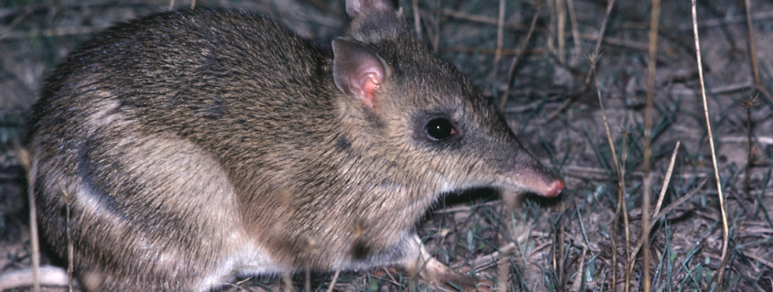
Breeding and reintroduction programs
Activity 2

Breeding and reintroduction programs
(Level 7)
Rod Bird ©
Mt Rothwell has several animal breeding and reintroduction programs. You will explore these in the following activity.
- Access the BWVP Mt Rothwell Virtual Tour. Look up point 7B and read how mammal reintroductions benefit mammal populations. Reintroduced mammal species do not generally survive in the wild without assistance. Why?
_____________________________________________________________________________________
_____________________________________________________________________________________

- Access the following points, 1D, 7B, 11D, 11E and use this information together with the DEPI Advisory List provided, or http://www.depi.vic.gov.au/__data/assets/pdf_file/0019/210439/Advisory-List-of-Threatened-Vertebrate-Fauna_FINAL-2013.pdf , to answer the following questions.
Identify the mammals that are part of the breeding and reintroduction programs at Mt Rothwell.
_____________________________________________________________________________________
_____________________________________________________________________________________

- What does the DEPI Advisory List outline?
_____________________________________________________________________________________
_____________________________________________________________________________________

- Identify the DEPI Advisory List conservation categories in order from the most extreme classification.
_____________________________________________________________________________________
_____________________________________________________________________________________

- Find the conservation status for each of the above animals using the DEPI Advisory List, and list the causes of decline using the information within the Mt Rothwell Virtual Tour.

Name of animal | Conservation status in Victoria | Causes of decline

- What does the conservation status for each animal mean for the population? (HINT: Look up the DEPI Advisory List definition for each conservation status category).
_____________________________________________________________________________________
_____________________________________________________________________________________
_____________________________________________________________________________________
_____________________________________________________________________________________
_____________________________________________________________________________________
_____________________________________________________________________________________
_____________________________________________________________________________________
_____________________________________________________________________________________

- Why is it important for Mt Rothwell and other animal sanctuaries to undertake breeding and reintroduction programs?
_____________________________________________________________________________________
_____________________________________________________________________________________

- Mt Rothwell has a number of successful breeding and reintroduction programs. What initiatives are undertaken to ensure the success of these programs?
_____________________________________________________________________________________
_____________________________________________________________________________________

Conclusion
- Mt Rothwell has successfully bred a range of mammals for what purpose?
_____________________________________________________________________________________
_____________________________________________________________________________________

- In order to conduct a successful breeding and reintroduction program what is required?
_____________________________________________________________________________________
_____________________________________________________________________________________

