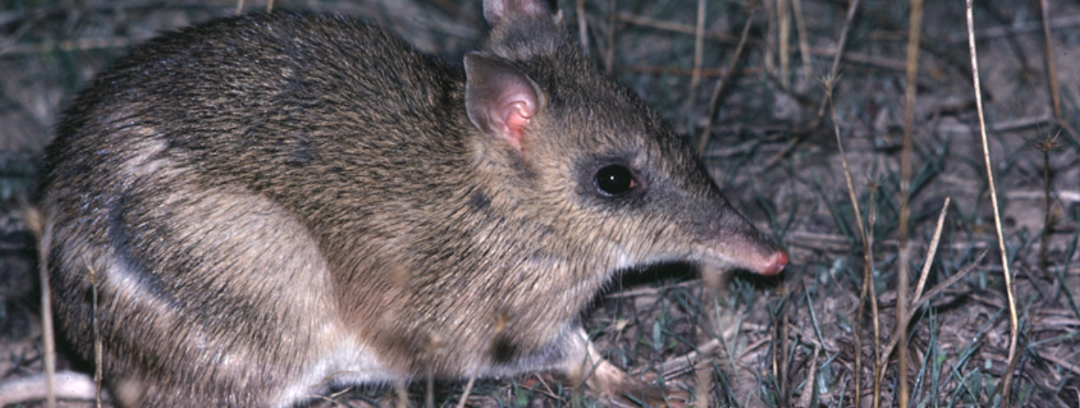
Comparing plant and animal adaptations
Activity 2

Comparing plant and animal adaptations
(Level 5)
Rod Bird ©
Investigate the adaptations of grassland and granite outcrop organisms within the BWVP Mt Rothwell Virtual Tour by completing the following questions.
- Access each of the points along the trail from the aerial map view and study the features to determine whether the point is found in a grassland or granite outcrop. Record your results in the table below.
Point | Grassland habitat | Granite outcrop habitat
1
2
3
4
5
6
7
8
9
10
11

- Describe the granite outcrop habitat?
_____________________________________________________________________________________
_____________________________________________________________________________________

- Describe the grassland habitat?
_____________________________________________________________________________________
_____________________________________________________________________________________

All organisms have adaptations that enable them to survive and thrive. Some adaptations are structural, which are physical features of an organism e.g. the beak of a bird. Other adaptations are behavioural. These are the behaviours an organism uses to survive e.g. a bird’s call.

You will identify some structural adaptations of animals and determine why the animal lives in a particular habitat.
- Identify three animals that live in the grassland and granite outcrop habitats. Use the BWVP Flora and Fauna Field Guide to determine their structural adaptations or physical characteristics (look up the identifying characteristics and distinctive markings).

Grassland fauna | Physical characteristics | Granite outcrop fauna | Physical characteristics

- Could the selected animals live in one or both habitats?
_____________________________________________________________________________________
_____________________________________________________________________________________
_____________________________________________________________________________________
_____________________________________________________________________________________

- Look up the following points along the trail to find an example of a plant or animal adaptation. Identify whether it is a behavioural or structural adaptation.
Point | Name of plant or animal | Adaptation | Structural or behavioural adaptation
3B
3D
6A
6C
8D
8E

Conclusion
- How does the granite outcrop and grassland habitat vary?
_____________________________________________________________________________________
_____________________________________________________________________________________
_____________________________________________________________________________________
_____________________________________________________________________________________

- Identify animals found in the granite outcrop?
_____________________________________________________________________________________
_____________________________________________________________________________________

- Identify animals found in the grassland habitat?
_____________________________________________________________________________________
_____________________________________________________________________________________

- What is the difference between a structural and behavioural adaptation?
_____________________________________________________________________________________
_____________________________________________________________________________________

- Identify an adaptation for a grassland plant or animal. Note whether this is structural or behavioural.
_____________________________________________________________________________________
_____________________________________________________________________________________

- Identify an adaptation for a granite outcrop plant or animal. Note whether this is structural or behavioural.
_____________________________________________________________________________________
_____________________________________________________________________________________

