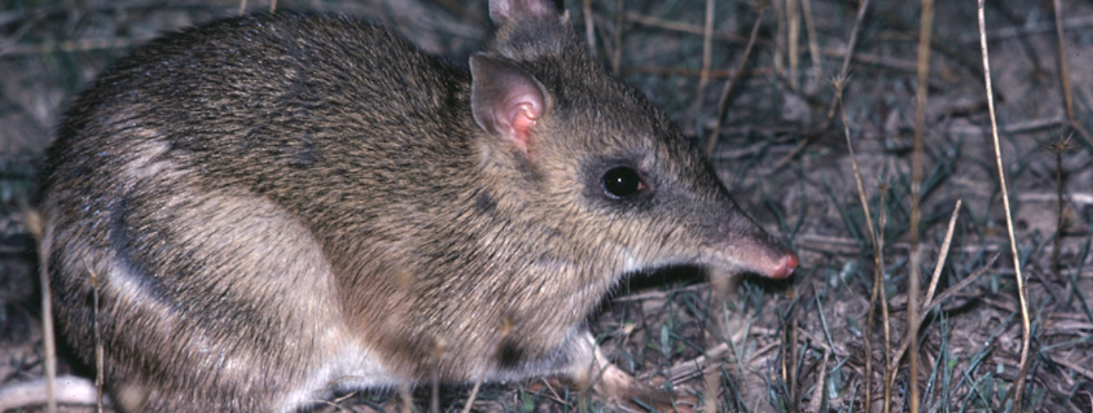
Living things depend on each other
Activity 2

Living things depend on each other
(Level 4)
Rod Bird ©
Your task is to investigate how plants and animals at Mt Rothwell depend on each other and the environment to survive. Access the BWVP Mt Rothwell Virtual Tour and examine the following points along the trail to explore relationships between plants and animals.
- Point 2A.
- How do dead eucalypts help to recycle nutrients?
_____________________________________________________________________________________
_____________________________________________________________________________________
- Which animals use hollows as nesting sites?
_____________________________________________________________________________________

- Point 2C.
  - What do living eucalypts provide for animals?
_____________________________________________________________________________________
  - Give an example of how living eucalypts are used during the day?
_____________________________________________________________________________________
  - Give an example of how living eucalypts are used during the night?
_____________________________________________________________________________________
  - How do other plants interact with eucalypts?
_____________________________________________________________________________________

- Point 3C.
  - Look up the glossary and define a symbiotic relationship.
_____________________________________________________________________________________
_____________________________________________________________________________________
  - What are lichens? Circle the correct answer.
Lichens are plants Lichens are animals
  - Explain how lichens are formed? Is this an example of a symbiotic relationship?
_____________________________________________________________________________________
_____________________________________________________________________________________
- Point 3D.
  - What are mosses? Circle the correct answer.
Mosses are plants Mosses are animals
  - Explain how mosses work together to improve their chances of survival.
_____________________________________________________________________________________
_____________________________________________________________________________________

- Point 4B. Identify three ways in which the Black Wattle benefits other animals and plants.
_____________________________________________________________________________________
_____________________________________________________________________________________
_____________________________________________________________________________________

- Search through the other points on the trail to find other examples of how plants and animals rely on each other and the environment to survive. Find two examples and describe the relationships.
_____________________________________________________________________________________
_____________________________________________________________________________________
_____________________________________________________________________________________
_____________________________________________________________________________________
_____________________________________________________________________________________
_____________________________________________________________________________________

Conclusion
- Choose one relationship and summarise how the plants/animals depend on each other and their environment. Make sure you mention how this benefits the plants and animals.
_____________________________________________________________________________________
_____________________________________________________________________________________

- Why do plants and animals rely on each other and the environment to survive?
_____________________________________________________________________________________
_____________________________________________________________________________________

