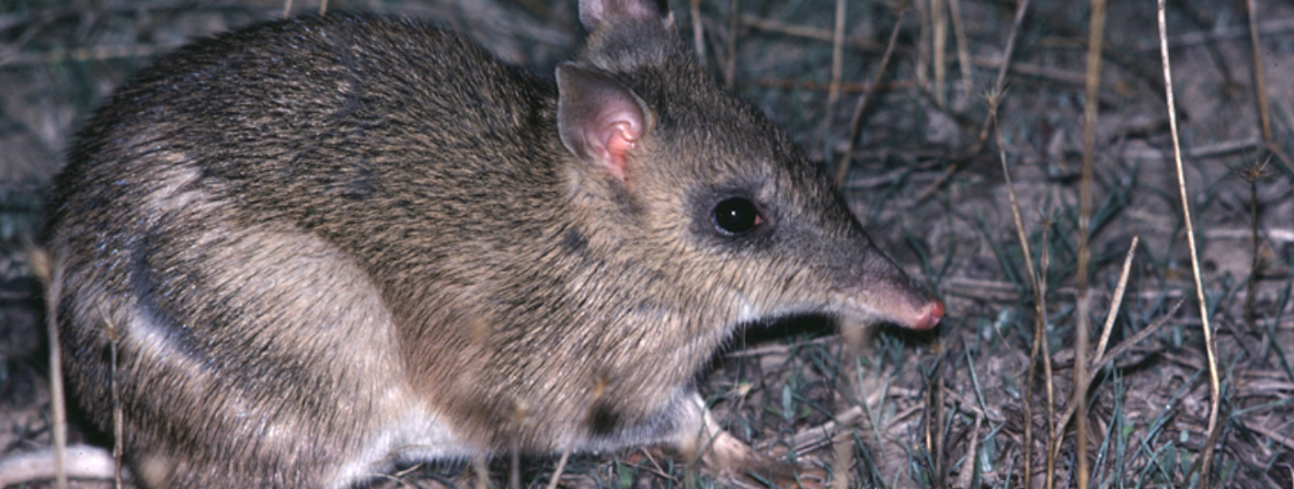
Duration
Rod Bird ©
Activity 2
Breeding and reintroduction programs

Objectives
After completing this activity, students will be able to:
- Identify how human activity can have a positive impact on the environment
- Investigate the requirements of breeding and reintroduction programs.

Target audience
Year 7

One 50-minute session

Materials
- Student worksheet
- Pencil
- Class set of computers with access to the BWVP Mt Rothwell Virtual Tour (internet access is required)
- Class set of the DEPI Advisory List of Threatened Vertebrate Fauna in Victoria (word document) or access http://www.depi.vic.gov.au/__data/assets/pdf_file/0019/210439/Advisory-List-of-Threatened-Vertebrate-Fauna_FINAL-2013.pdf

Activity
Before beginning the activity
This activity focuses on the breeding and reintroduction programs at Mt Rothwell. Using the BWVP Mt Rothwell Virtual Tour, students study the programs and evaluate the benefits for the environment.

Carrying out the activity
- Students access the Mt Rothwell Virtual Tour using their computers and follow the instructions provided in their worksheets. They will investigate several points along the trail in order to answer set questions as required.
- Students will use the DEPI Advisory List in Question 4 to define each of the conservation status categories (page 3 of the Advisory List). You may like to go through the meaning of these with the class.
- Students should share their findings with the class. Ask students to discuss their findings. Students will then complete the conclusion questions.

Breeding and reintroduction programs
Mt Rothwell has several animal breeding and reintroduction programs. You will explore these in the following activity.
- Access the BWVP Mt Rothwell Virtual Tour. Look up point 7B and read how mammal reintroductions benefit mammal populations. Reintroduced mammal species do not generally survive in the wild without assistance. Why?
Reintroduced mammal species do not generally survive in the wild due to threats posed by feral species and habitat loss.
- Access the following points, 1D, 7B, 11D, 11E and use this information together with the DEPI Advisory List provided, or http://www.depi.vic.gov.au/__data/assets/pdf_file/0019/210439/Advisory-List-of-Threatened-Vertebrate-Fauna_FINAL-2013.pdf , to answer the following questions. Identify the mammals that are part of the breeding and reintroduction programs at Mt Rothwell.
Brush-tailed Rock Wallaby, Eastern Quoll, Bush-stone Curlew and Eastern Barred Bandicoot.
- What does the DEPI Advisory List outline?
The DEPI Advisory List outlines the conservation status of threatened vertebrates in Victoria.
- Identify the DEPI Advisory List conservation categories in order from the most extreme category.
Extinct, Regionally Extinct, Extinct in the Wild, Critically Endangered, Endangered, Vulnerable, Near Threatened, Data Deficient.
- Find the conservation status for each of the above animals using the DEPI Advisory List, and list the causes of decline using the information within the Mt Rothwell Virtual Tour.
Name of animal | Conservation status in Victoria | Causes of decline
Brush-tailed Rock Wallaby | Critically Endangered | Foxes and feral cats, competition with feral grazers, diseases such as toxoplasmosis and hydatidosis, are carried by feral cats and foxes.
Eastern Quoll | Regionally Extinct | Loss of grassland habitat, the disease toxoplasmosis, which is carried by cats and predation by introduced species including foxes.
Bush-stone Curlew | Endangered | Fox predation and habitat destruction.
Eastern Barred Bandicoot | Extinct in the Wild | Loss of habitat, introduction of foxes and cats.
- What does the conservation status for each animal mean for the population? (HINT: Look up the DEPI Advisory List definition for each conservation status category).
Brush-tailed Rock Wallaby – Critically Endangered means that the wallaby population is facing an extremely high risk of extinction in the wild.
Eastern Quoll – Regionally Extinct means that the quoll has not been seen in the wild (within Victoria), despite exhaustive surveys in known and/or expected habitats.
Bush-stone Curlew – Endangered means that the curlew is facing a very high risk of becoming extinct in the wild.
Eastern Barred Bandicoot – Extinct in the wild means that the Eastern Barred Bandicoot has not been seen in the wild, despite exhaustive surveys in known and/or expected habitats. Some species that are extinct in the wild are known only to survive in captivity and/or as naturalized populations well outside their past range.
- Why is it important for Mt Rothwell and other animal sanctuaries to undertake breeding and reintroduction programs?
Without breeding and reintroduction programs, threatened and endangered species may become extinct.
- Mt Rothwell has a number of successful breeding and reintroduction programs. What initiatives are undertaken to ensure the success of these programs?
A feral proof fence and management of weeds are other initiatives implemented at Mt Rothwell to ensure successful breeding and reintroduction programs.

Conclusion
- Mt Rothwell has successfully bred a range of mammals for what purpose?
Many animal species have been bred at Mt Rothwell to be relocated into other feral proof areas or suitable habitats.
- In order to have a successful breeding program and reintroduction program what is required?
Feral proof fences and appropriate habitats are both required at a site to ensure a successful breeding and reintroduction program.

