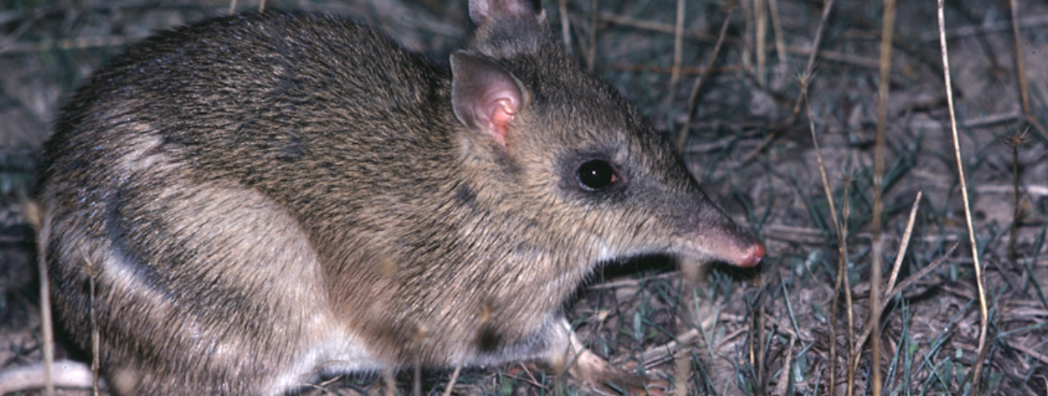
Duration
Rod Bird ©
Activity 2
Grassland to granite outcrop

Objectives
After completing this activity, students will be able to:
- Compare grassland and granite outcrop habitats
- Demonstrate that the growth and survival of living things is affected by their environment.

Target audience
Year 6

One 50-minute session

Materials
- Student worksheet
- Pencil
- Class set of computers with access to the BWVP Mt Rothwell Virtual Tour (internet access is required) and the BWVP Flora and Fauna Field Guide (on iPhone or iPad) or on the Ecolinc BWVP website (internet access is required)

Activity
Before beginning the activity
This activity focuses on the comparison of two habitats at Mt Rothwell. Using the BWVP Mt Rothwell Virtual Tour, students study a granite outcrop and a grassland habitat. Discuss with students the characteristics of each habitat, how these habitats might vary and whether the flora and fauna would be similar or different.

Carrying out the activity
- Students access the BWVP Mt Rothwell Virtual Tour on their computers. Initially ask students to look at the aerial map view to identify the locations of the grassland and granite outcrop habitats. A grassland is treeless and is dominated by grasses and herbs. A granite outcrop is an exposure of granite rock (a very hard, igneous rock), with grasses, occasional shrubs and trees.
- Ask students to click on each of the 11 points along the trail from the aerial map view, look at the images and determine whether the point is located in the grassland or granite outcrop. Points 1, 2 and 11 are grassland sites, while points 3, 4, 5, 6, 7, 8, 9 and 10 are granite outcrops. Students should then complete Questions 1-3 in their workbooks.
- Students select appropriate points to identify four grassland animals and four granite outcrop animals. Using the BWVP Flora and Fauna Field Guide, look up each animal and find their habitat requirements. Mt Rothwell is at the edge of the Western Volcanic Plain and as a result some of the animals do not appear in the BWVP Flora and Fauna Field Guide. Therefore students should select another animal or find the information using another source, e.g. Museum Victoria Field Guide to Victorian Fauna. List these in Question 4 and then complete the remaining questions, discussing findings.
- Students should share their findings with the class. Students should then complete the conclusion questions.

Grassland to granite outcrop
Investigate the flora and fauna of the grassland and granite outcrop habitats within the Mt Rothwell Virtual Tour by completing the following questions.
- Access each of the points along the trail from the aerial map view and study the features to determine whether the point is found in a grassland or granite outcrop. Record your results in the table below.
Point | Grassland habitat | Granite outcrop habitat
1 | ✓
2 | ✓
3 |  | ✓
4 |  | ✓
5 |  | ✓
6 |  | ✓
7 |  | ✓
8 |  | ✓
9 |  | ✓
10 |  | ✓
11 | ✓

- Describe the granite outcrop habitat?
The granite outcrop is a dry, open eucalypt woodland to 15 m tall, often with a sparse shrub layer. The understorey is dominated by a carpet of herbs and grasses. There are undulating, rounded granite hill landforms.
- Describe the grassland habitat?
A grassland habitat is treeless, with vegetation mostly < 1 m, dominated by large grasses and herbs.

- Use the BWVP Virtual Tour to find animals that live in each habitat. Use the BWVP Flora and Fauna Field Guide to determine habitat requirements and then complete the table.
Grassland fauna | Habitat requirements | Granite outcrop fauna | Habitat requirements

- Why do animals that live in a grassland and/or granite outcrop live in these habitats?
Animals live in these habitats to meet their specific requirements for survival. Animals require a particular food source, shelter and breeding requirements to survive.
- What other animals could live in grassland and granite outcrop habitats?
Other animals that could be found at Mt Rothwell include, other birds of prey, frogs, invertebrates and reptiles.

Conclusion
- How does a granite outcrop and grassland habitat vary?
The granite outcrop is a very rocky habitat with the occasional trees and shrubs, whereas the grassland is treeless. Some basalt outcrops may be found in grasslands.
- Identify animals found in the granite outcrop?
Students should mention the animals they have investigated. These could include mammals such as the Brush-tailed Rock Wallaby, reptiles such as the Common Blue-tongue Lizard and birds such as the Wedge-tailed Eagle.
- Identify animals found in the grassland habitat?
Students should mention the animals they have investigated. These could include: mammals such as the Rufous Bettong and birds such as the Bush-stone Curlew.
- Do the animals vary between habitats? Why?
Yes, the animals do vary between habitats. Each habitat provides different resources and animals have specific requirements. Therefore if the habitat does not provide the correct breeding conditions and food for instance, the animal may not survive.
- Explain how the environment affects the growth and survival of living things at Mt Rothwell.
Animals and plants depend on the environment to provide appropriate resources including food and nutrients, shelter and reproduction requirements.

