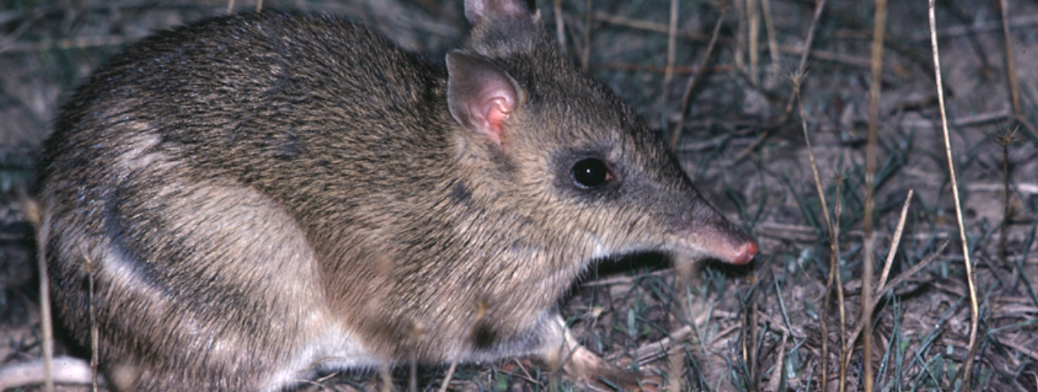
Duration
Rod Bird ©
Activity 2
Living things depend on each other

Objectives
After completing this activity, students will be able to:
- Explore the BWVP Mt Rothwell Virtual Tour
- Explain how plants and animals depend on each other and their environment to survive.

Target audience
Year 4

One 50-minute session

Materials
- Student worksheet
- Pencil
- Class set of computers with access to the BWVP Mt Rothwell Virtual Tour (internet access required)

Activity
Before beginning the activity
This activity focuses on how plants and animals at Mt Rothwell rely on each other and the environment to survive. Using the BWVP Mt Rothwell Virtual Tour, students investigate how plants and animals interact with one another. Discuss with students what some of these relationships could be.

Carrying out the activity
- Students access the Mt Rothwell Virtual Tour on their computers. In Questions 1-5 students are asked to find certain points along the trail in order to answer questions about interactions between plants, animals and the environment.
- Students will then click on each of the 11 points from the aerial map view, read the content and search for examples of interactions between plants, animals and the environment. They will note these for Question 6, then write down their findings in Question 7.
- Students should share their findings with the class. Ask students to discuss their findings. Students will then complete the conclusion questions.

Living things depend on each other
Your task is to investigate how plants and animals at Mt Rothwell depend on each other and the environment to survive. Examine the following points along the trail to explore relationships between plants and animals.
- Point 2A.
- How do dead eucalypts help to recycle nutrients?
When branches fall to the ground, termites, fungi and bacteria begin to break down and decompose the wood, which returns nutrients back to the soil.
- Which animals use hollows as nesting sites?
Birds, bats and mammals use hollows as nesting sites.
- Point 2C.
- What do living eucalypts provide for animals?
Living eucalypts provide food and shelter.
- Give an example of how living eucalypts are used during the day?
Birds and insects may be seen feeding on flowering eucalypts, amongst the leaves and on the trunk.
- Give an example of how living eucalypts are used during the night?
Possums may be observed moving around the upper limbs.
- How do other plants interact with eucalypts?
Mistletoe may be seen growing on box eucalypts.
- Point 3C.
- Look up the glossary and define a symbiotic relationship.
A symbiotic relationship is a close relationship between the individuals of two or more different species.

- What are lichens? Circle the correct answer.
Lichens are plants Lichens are animals
- Explain how lichens are formed? Is this an example of a symbiotic relationship?
Lichens are formed from a fungus and an alga living in a close relationship. Each benefits from the relationship. Yes, the relationship between the fungus and alga is an example of a symbiotic relationship.
- Point 3D.
- What are mosses? Circle the correct answer.
Mosses are plants Mosses are animals
- Explain how mosses work together to improve their chances of survival.
Mosses have no vascular system to transport water or nutrients. Therefore they grow near moisture in a group to support one another and to retain moisture.
- Point 4B. Identify three ways in which the Black Wattle benefits other animals and plants.
1. Provides nutrients to the soil by fixing nitrogen from the atmosphere.
2. Crevices in the bark provide habitat for many invertebrates.
3. In winter, insects, birds and marsupials feed on the nectar.
- Search through the other points on the trail to find other examples of how plants and animals rely on each other and the environment to survive. Find two examples and describe the relationships.
Below is a list of points, which indicate the relationships between plants/animals and the environment;
2E: Superb Fairy-Wren – requires habitats with dense cover and low shrubs for protection.
3B: Sheoaks – have developed a symbiotic relationship with mycorrhizal fungi, enabling them to fix their own nitrogen (which is needed for growth). Small marsupials including bandicoots, bettongs and potoroos, eat the fungal truffle fruiting bodies.
3E: Sulphur-crested Cockatoo – nests in large hollow limbs or tree trunks ~10m above the ground.
5C: Australian Magpie – builds their nests high in a tree fork, mostly in tall eucalypts.
6A: Tawny Frogmouth – can be seen during the day or at night camouflaged on a branch. They have silver-grey plumage and cryptic poses which may make them difficult to see.
6C: Hedge Wattle – birds rely on this plant for protection, as they have dense growth and sharp spines. This wattle provides ideal nesting sites for the Superb Fairy-wren and the White-browed Scrub Wren.
8D: Red-rumped Parrot – camouflages very easily when feeding on the ground amongst the open grasses.
9D: Swamp Wallaby – uses dense vegetation to hide from predators.
- What do your findings tell you about interactions between plants, animals and the environment?
Students should be able to list many different interactions between plants, animals and the environment. These interactions enable plants and animals to survive.

Conclusion
- Choose one relationship and summarise how the plants/animals depend on each other and their environment. Make sure you mention how this benefits the plants and animals.
Students will summarise the details of one relationship.
- Why do plants and animals rely on each other and the environment to survive?
There is little chance of an organism surviving without relying on other species and the environment. Plants and animals rely on other species and/or the environment for protection, breeding and a food source.

