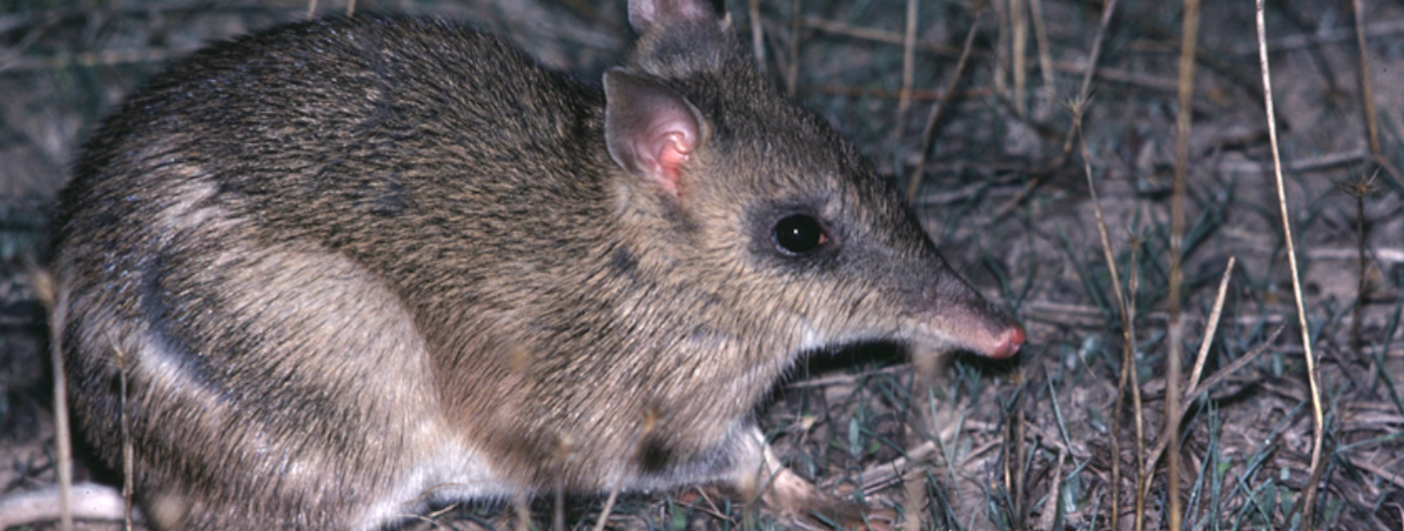
Duration
Rod Bird ©
Activity 1
Exploring the Virtual Tour

Objectives
After completing this activity, students will be able to:
- Explore the BWVP Mt Rothwell Virtual Tour and the BWVP Flora and Fauna Field Guide
- Investigate native and introduced flora and fauna.

Target audience
Years 4 - 7

One 50-minute session

Materials
- Student worksheet
- Pencil
- Class set of computers with access to the BWVP Mt Rothwell Virtual Tour (internet access is required) and the BWVP Flora and Fauna Field Guide (on iPhone or iPad) or on the Ecolinc BWVP website (internet access is required)

Activity
Before beginning the activity
This activity focuses on the exploration of Mt Rothwell using the Mt Rothwell Virtual Tour. Mt Rothwell is a 400 hectare property that has been established for the management of high conservation value flora and fauna species, including breeding and research programs. Mt Rothwell is the largest predator free ecosystem in Victoria. Granite outcrops, grassland and grassy woodland ecosystems are found at Mt Rothwell. This activity enables students to explore some of the flora and fauna found at Mt Rothwell.

Carrying out the activity
- Students access the BWVP Mt Rothwell Virtual Tour on their computers and ‘visit’ each of the 11 points marked on the aerial map view, to explore the content.
- Students will investigate the native and introduced flora and fauna found at Mt Rothwell by completing the following activity. Students will choose two native animals, two native plants, two introduced plants and two introduced animals. They will then complete the table in their workbooks, by identifying the relevant plants and animals, describing the habitat, diet, native status and group/type. Some of this information will be found within the Virtual Tour however students can also search for their plants or animals using the BWVP Flora and Fauna Field Guide to find the necessary information. As Mt Rothwell is at the edge of the Western Volcanic Plain, some of the Mt Rothwell species do not appear in the BWVP Flora and Fauna Field Guide. Therefore, students should select another species or find the information using another source, e.g. Museum Victoria Field Guide to Victorian Fauna.
- Students should share their findings with the class. Ask students to discuss their findings. Students should then complete the conclusion questions.

Exploring the Virtual Tour
Mt Rothwell is a 400 hectare property that has been established for the management of high conservation value flora and fauna species, including breeding and research programs. The Mt Rothwell Virtual Tour provides a tour of the property and profiles examples of the flora, fauna and other special features.
- Your task is to investigate examples of native and introduced flora and fauna at Mt Rothwell using the BWVP Mt Rothwell Virtual Tour. Find two examples of each of the following; native fauna, introduced fauna, native flora and introduced flora, and record these species in the table below. Most of the information can be found within the Mt Rothwell Virtual Tour, however you may wish to use the BWVP Flora and Fauna Field Guide to find additional information.

Common name | Scientific name | Habitat | Diet | Native status | Group/type

- What do your findings tell you about Mt Rothwell?
Students should suggest that there are many native flora and fauna species found at Mt Rothwell, some of which are classified as endangered or extinct on the mainland. Flora and fauna species are being managed on the site using various methods.

Conclusion
- Mt Rothwell is a sanctuary for native flora and fauna. Identify some of the native flora and fauna found on the site.
Students should identify those species investigated in Question 1. After a discussion with their peers they should be able to identify others.

- Identify the groups of fauna that can be found at Mt Rothwell?
The following groups of fauna can be found at Mt Rothwell: kangaroos, bettongs, bandicoots, wallabies, quolls, birds of prey, parrots, frogs, bats, lizards, cockatoos, stone-curlews, echidnas, moths, magpies and wrens.

- Identify the groups of flora that can be found at Mt Rothwell?
The following groups of flora can be found at Mt Rothwell: eucalypts, graminoids, lichens, mosses, wattles and sheoaks.

- Mt Rothwell aims to exclude introduced flora and fauna from the property. What introduced flora and fauna are being excluded?
The following flora and fauna are being actively excluded from Mt Rothwell: European Rabbits, Red Foxes, Feral Cats and introduced flora including Cape Weed.

