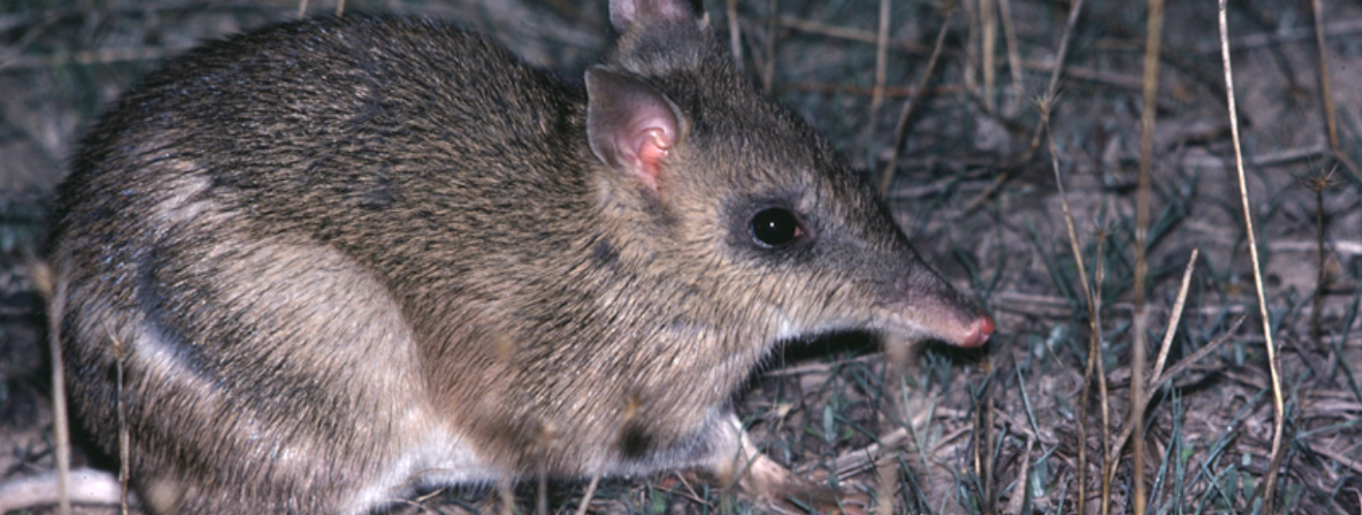
Comparing grassland to granite outcrop
Activity 2

Grassland to
granite outcrop
(Level 6)
Rod Bird ©
Investigate the flora and fauna of the grassland and granite outcrop habitats using the BWVP Mt Rothwell Virtual Tour, by completing the following questions.
- Access each of the points along the trail via the aerial map view and study the features to determine whether the point is found in a grassland or granite outcrop. Record your results in the table below.
Point | Grassland habitat | Granite outcrop habitat
1
2
3
4
5
6
7
8
9
10
11

- Describe the granite outcrop habitat?
_____________________________________________________________________________________
_____________________________________________________________________________________

- Describe the grassland habitat?
_____________________________________________________________________________________
_____________________________________________________________________________________

- Use the BWVP Virtual Tour to find animals that live in each habitat. Use the BWVP Flora and Fauna Field Guide to determine habitat requirements and then complete the table.
Grassland fauna | Habitat requirements | Granite outcrop fauna | Habitat requirements

- Why do animals that live in a grassland and/or granite outcrop live in these habitats?
_____________________________________________________________________________________
_____________________________________________________________________________________
_____________________________________________________________________________________
_____________________________________________________________________________________

- What other animals could live in grassland and granite outcrop habitats?
_____________________________________________________________________________________
_____________________________________________________________________________________
_____________________________________________________________________________________
_____________________________________________________________________________________

Conclusion
- How does a granite outcrop and grassland habitat vary?
_____________________________________________________________________________________
_____________________________________________________________________________________
_____________________________________________________________________________________

- Identify animals found in the granite outcrop?
_____________________________________________________________________________________
_____________________________________________________________________________________
_____________________________________________________________________________________
_____________________________________________________________________________________

- Identify animals found in the grassland habitat?
_____________________________________________________________________________________
_____________________________________________________________________________________

- Do the animals vary between habitats? Why?
_____________________________________________________________________________________
_____________________________________________________________________________________
_____________________________________________________________________________________
_____________________________________________________________________________________

- Explain how the environment affects the growth and survival of living things at Mt Rothwell.
_____________________________________________________________________________________
_____________________________________________________________________________________
_____________________________________________________________________________________
_____________________________________________________________________________________

