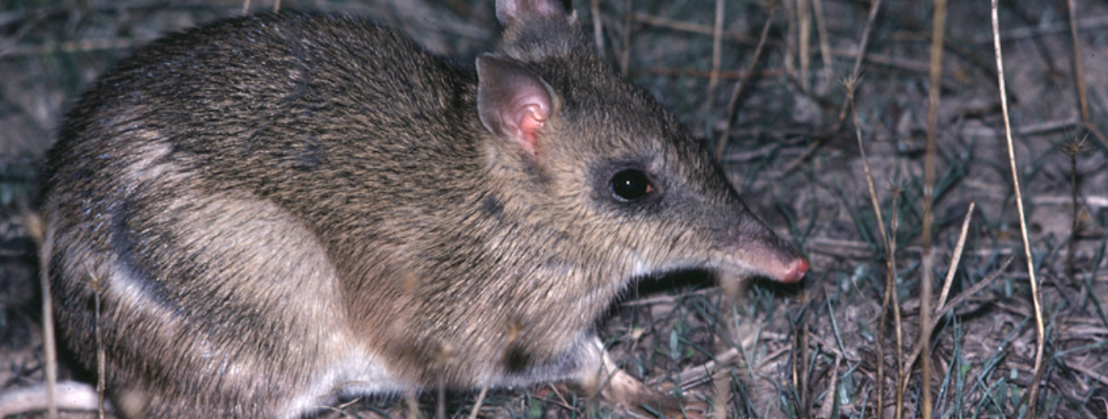
Exploring the Virtual Tour
Activity 1

Exploring the Virtual Tour
(Levels 4-7)
Rod Bird ©
Mt Rothwell is a 400 hectare property that has been established for the management of high conservation value flora and fauna species, including breeding and research programs. The Mt Rothwell Virtual Tour provides a tour of the property, and profiles examples of the flora, fauna and other special features.
- Your task is to investigate the native and introduced flora and fauna at Mt Rothwell using the BWVP Mt Rothwell Virtual Tour. Find two examples of each of the following; native fauna, introduced fauna, native flora and introduced flora, and record these in the table below. Most of the information can be found within the Mt Rothwell Virtual Tour, however you may wish to use the BWVP Flora and Fauna Field Guide to find additional information.

Common name | Scientific name | Habitat | Diet | Native status | Group/type

- What do your findings tell you about Mt Rothwell?
_____________________________________________________________________________________
_____________________________________________________________________________________
_____________________________________________________________________________________

Conclusion
- Mt Rothwell is a sanctuary for native flora and fauna. Identify some of the native flora and fauna found on the site.
_____________________________________________________________________________________
_____________________________________________________________________________________

- Identify the groups of fauna that can be found at Mt Rothwell?
_____________________________________________________________________________________
_____________________________________________________________________________________

- Identify the groups of flora that can be found at Mt Rothwell?
_____________________________________________________________________________________
_____________________________________________________________________________________

- Mt Rothwell aims to exclude introduced flora and fauna from the property. What introduced flora and fauna are being excluded?
_____________________________________________________________________________________
_____________________________________________________________________________________

